Audience
This Tableau dashboard is designed for U.S. air travelers who pass through TSA security checkpoints on a regular basis. This audience is broad and non-technical: they are familiar with the experience of airport screening but are unlikely to know how to file a formal TSA complaint, interpret large datasets, or understand agency accountability structures. They are motivated by personal frustration and a desire to know whether their experiences are shared, whether conditions are improving or worsening, and which airports or issues are most problematic.
Purpose
The purpose of this dashboard is to inform and empower. It aims to reveal the scale and ten-year trend of TSA complaints and to show travelers which airports generate the most complaints. Critically, the dashboard closes with a direct call to action: encouraging travelers to file complaints when their rights are violated and prompting policymakers to direct reform efforts toward the highest-complaint airports and subcategories.
Medium
Tableau was selected as the delivery medium because it supports rich interactivity without requiring the audience to install software or possess data literacy. An interactive dashboard allows travelers to filter by airport or year, making the story personally relevant rather than abstract.
Design
The dashboard opens with a full-width trend line to establish the central tension of the story: complaints did not simply recover after COVID-19, they hit an all-time high. A bubble map then grounds the audience geographically, answering “which airports are worst?” A stacked area chart runs alongside it to show what travelers are complaining about and how category mix has shifted over time.
The heatmap satisfies the required complex visual type and adds a time dimension to the airport ranking. The box plot reveals distributional variability: some airports are consistently high while others have extreme seasonal outliers. Finally, the treemap uses the subcategory dataset to drill into the specific complaint types within each category, surfacing the finding that TSA PreCheck issues are themselves a leading complaint driver.
Visuals
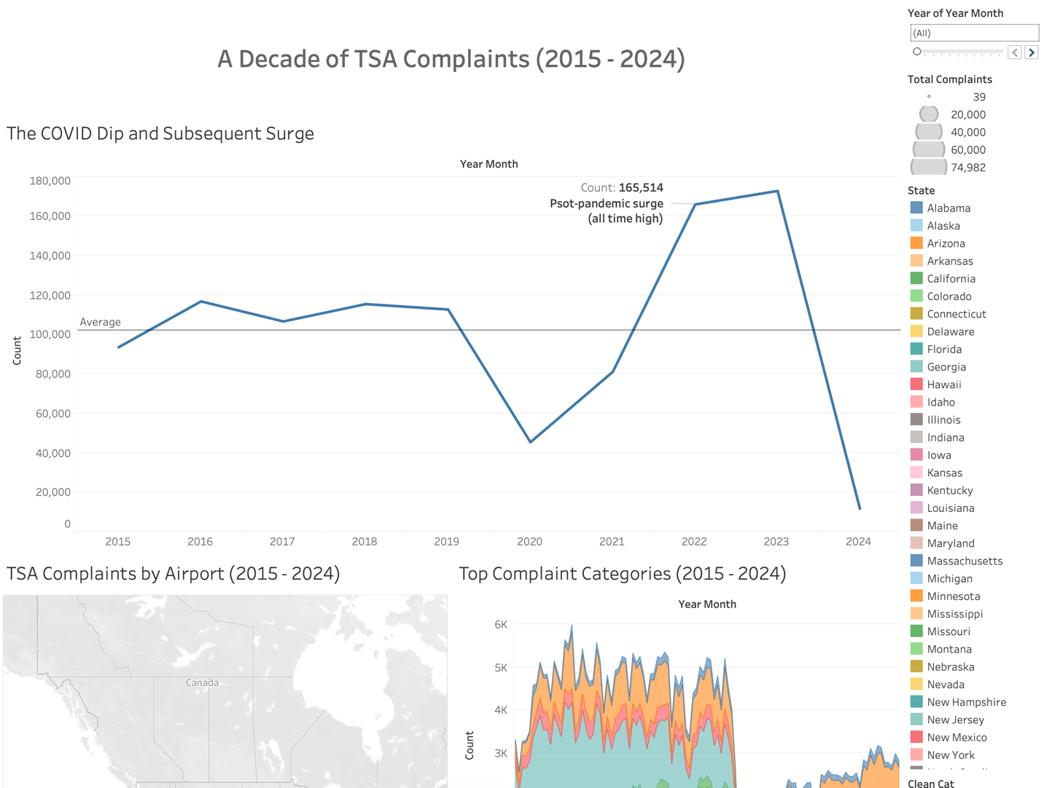
Ethical Considerations
The complaint data captures only travelers who knew how to file a TSA complaint and chose to do so. This systematically underrepresents travelers with limited English proficiency, lower digital literacy, or those who distrust government reporting channels. Underserved communities are therefore likely underrepresented in the civil rights complaint figures.
Raw complaint counts favor large airports with more passengers. The bubble map uses absolute counts. Color scales across all charts are perceptually uniform sequential palettes to avoid misleading magnitude impressions.
Naming specific airports could be perceived as reputational attack. However, all data is sourced from official TSA public records and is presented in aggregate with no individual complaint data shown. The intent is systemic accountability rather than individual blame. The call to action of “Visit TSA.gov/contact or call 1-866-289-9673” directs travelers toward the official complaint mechanism, reinforcing the civic purpose of the visualization and ensuring the dashboard empowers rather than misleads.

